Step 1:
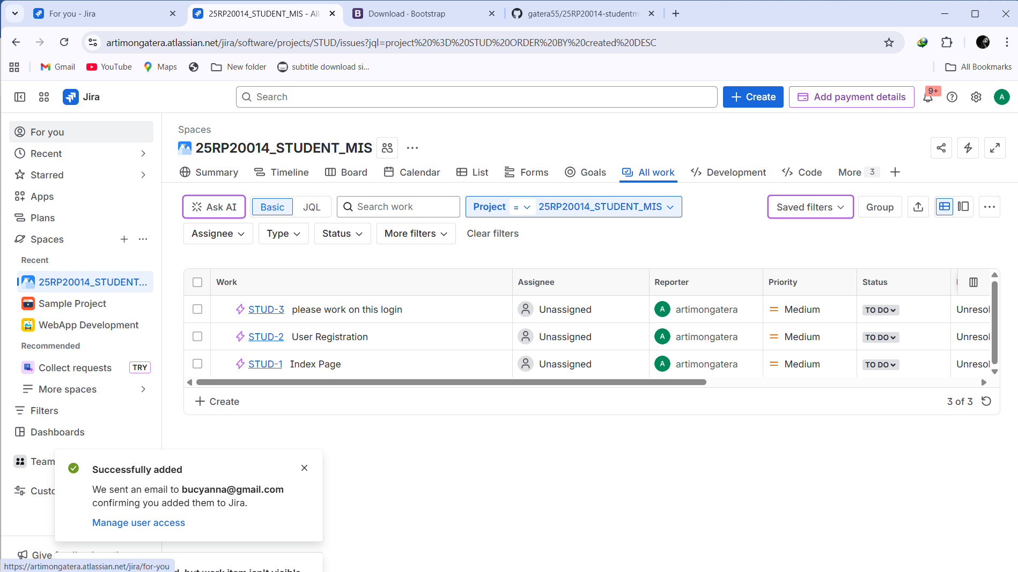
Step 2:
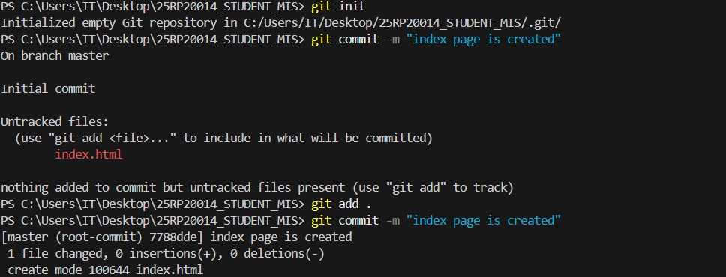

Step 3:
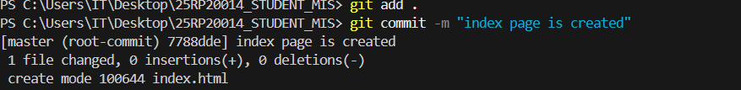
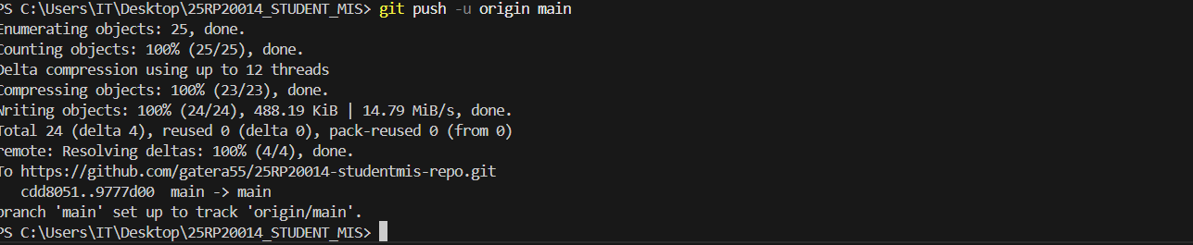
Step 4:
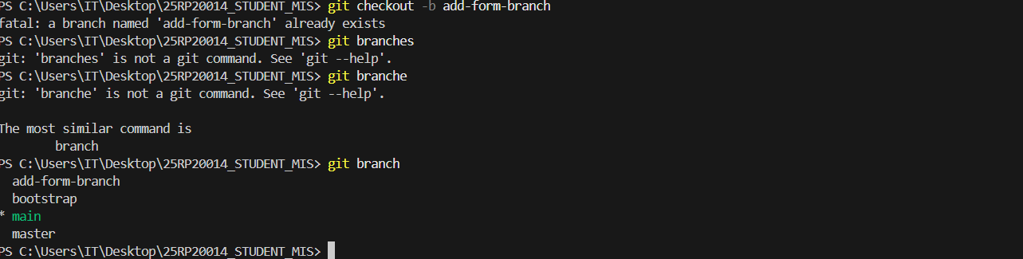

Step 5:
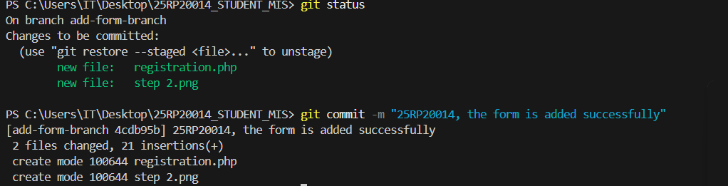
Step 6:
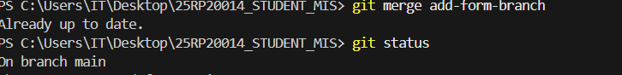
Step 7:
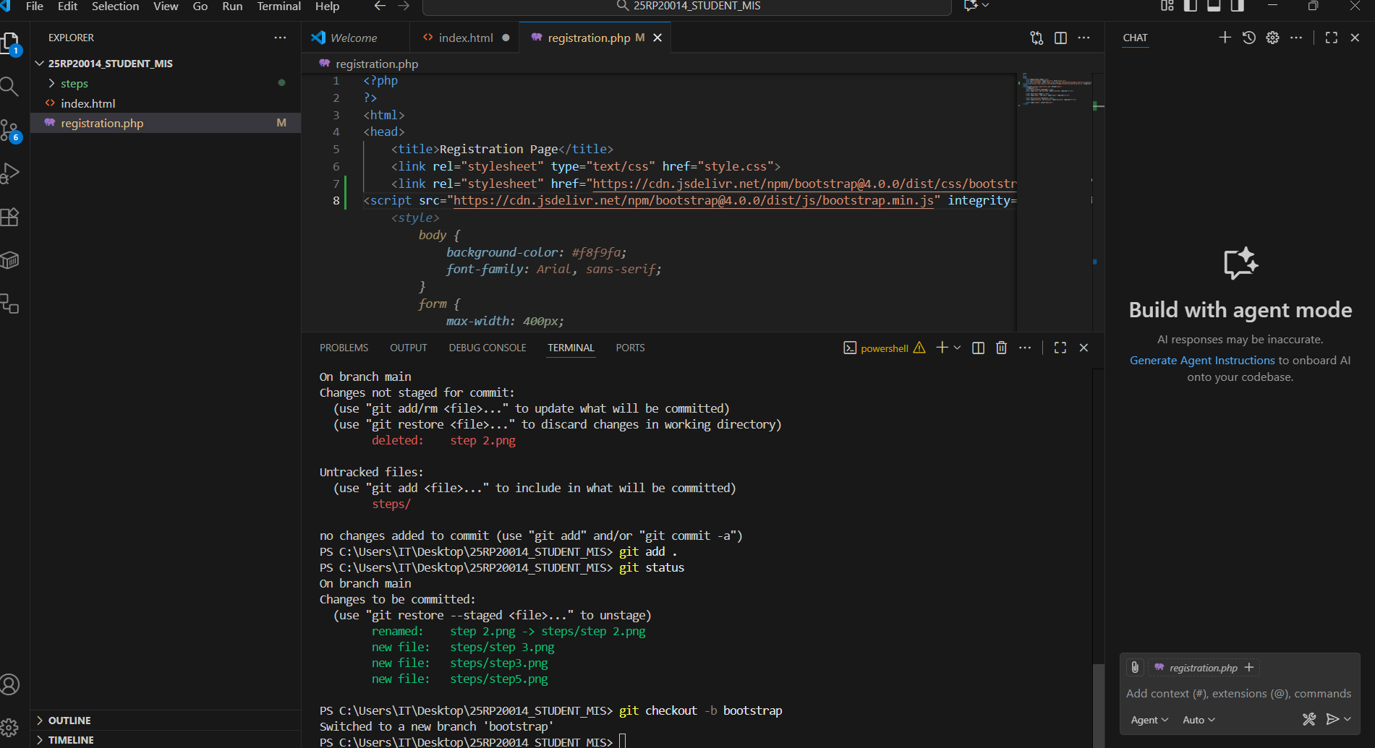

Step 8:
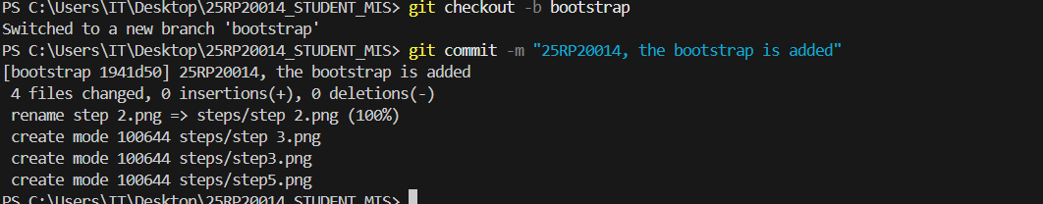

Step 9:
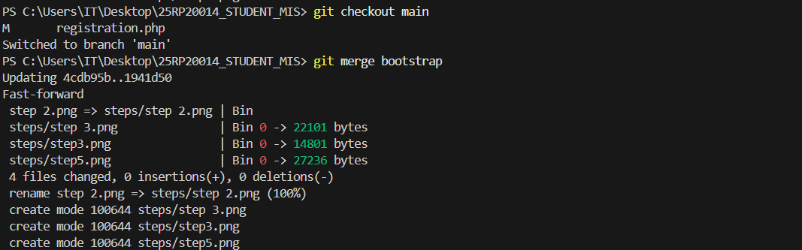
Step 10:
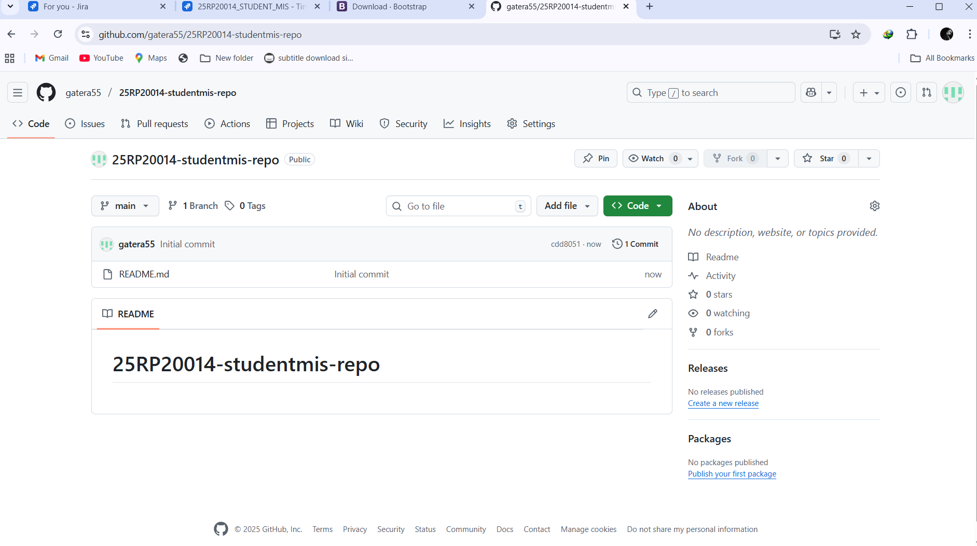
Step 11:
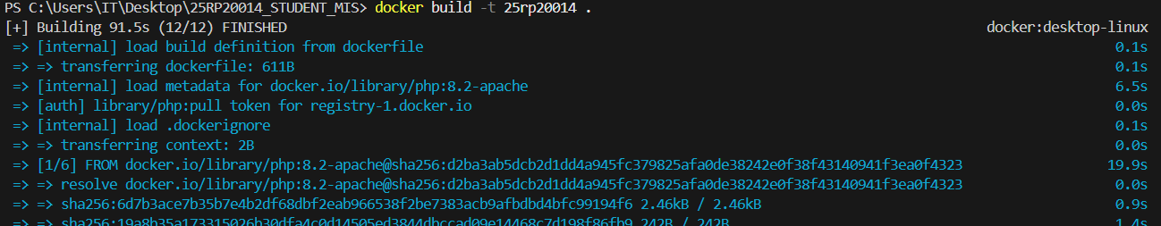
Step 12:

Step 13:
Step 14:
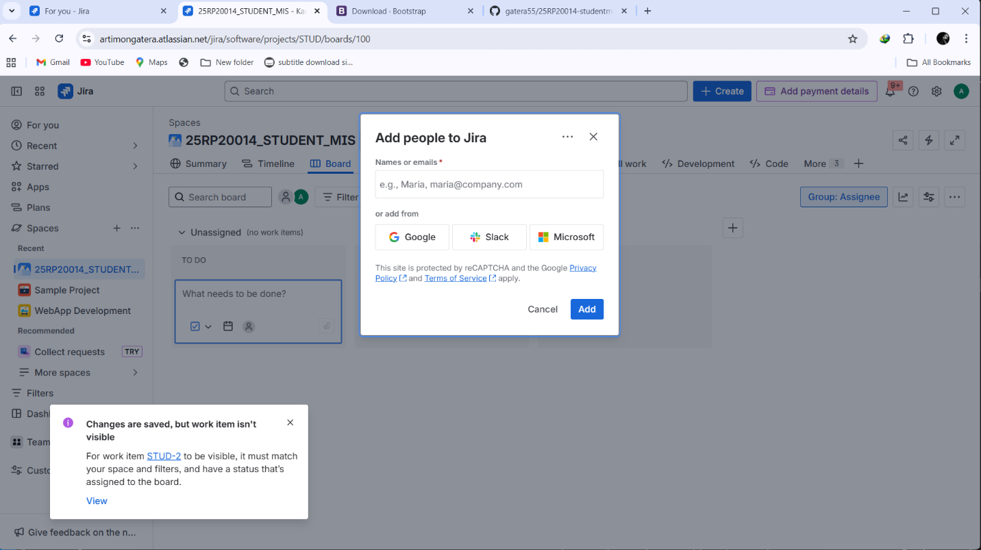
Step 15:
